Program -5

**Aim: Linear Search and Binary search in Python.**

**Code:**

**Linear Search:**

def LinearSearch(array, n, k):  
 for j in range(0, n):  
 if (array[j] == k):  
 return j  
 return -1  
array = [1, 3, 5, 7, 9]  
k = 7  
n = len(array)  
result = LinearSearch(array, n, k)  
if (result == -1):  
 print("Element not found")  
else:  
 print("Element found at index: ", result)

**Output:**

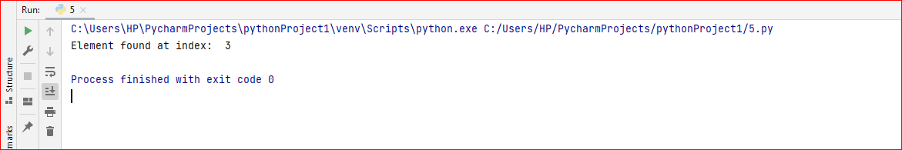

**Binary Search:**

def binarySearch(arr, k, low, high):  
 while low <= high:  
 mid = low + (high - low) // 2  
 if arr[mid] == k:  
 return mid  
 elif arr[mid] < k:  
 low = mid + 1  
 else:  
 high = mid - 1  
 return -1  
arr = [1, 3, 5, 7, 9]  
k = 5  
result = binarySearch(arr, k, 0, len(arr) - 1)  
if result != -1:  
 print("Element is present at index " + str(result))  
else:  
 print("Not found")

**Output:**

